**Capstone Project - The Battle of Neighborhoods**

**Opening Turkish Restaurant in Bucharest**

**1. Introduction**

**1.1 Background**

Bucharest is the capital and largest city of Romania, as well as its cultural, industrial, and financial centre. It is located in the southeast of the country, at coordinates: 44°25′57″N 26°06′14″E, less than 60 km (37.3 mi) north of the Danube River and the Bulgarian border. [1]

Bucharest is the center of the Romanian economy and industry, accounting for around 24% (2017) of the country's GDP and about one-quarter of its industrial production, while being inhabited by 9% of the country's population. Bucharest has **2 million** populations and consists of **6 sectors**. Neighborhoods and populations in sectors are as below: [1]

* **Sector 1** *(population 227,717):* Dorobanți, Băneasa, Aviației, Pipera, Primăverii, Dămăroaia, Grivița
* **Sector 2** *(population 357,338):* Pantelimon, Colentina, Iancului, Tei, Floreasca, Moșilor, Obor, Fundeni,
* **Sector 3** *(population 399,231):* Vitan, Dudești, Titan, Centrul Civic, Dristor, Lipscani
* **Sector 4** *(population 300,331):* Berceni, Olteniței, Progresul, Văcărești, Tineretului
* **Sector 5** *(population 288,690):* Rahova, Ferentari, Giurgiului, Cotroceni, 13 Septembrie, Dealul Spirii
* **Sector 6** *(population 371,060):* Giulești, Crângași, Drumul Taberei, Militari, Grozăvești(Regie), Ghencea

As stated by the Mercer international surveys for **quality of life** in **231** cities around the world, Bucharest occupied the **109th** place in 2019. Bucharest, at number 109, ranks low in the European list but better than other European cities such as Sofia (116th) and Belgrade (139th). [2]

Many neighborhoods, particularly in the southern part of the city, lack sufficient green space, are formed of cramped high density block of flats. This may affect people’s life as well.

**1.2. Problem**

In this project, I will investigate that if there is any good location in Bucharest for opening Turkish restaurant and it really values to open one.

**1.3. Interest**

Anyone wants to open a new venue in any geographic location may be interested in this project by modifying search criteria.

**2. Data**

**2.1 Data sources**

To consider the problem we can list the data as below:

* I get the neighborhood data of Bucharest from Wikipedia [3]
* I use python geocoder library to get geographical coordinates of neighborhoods[4]
* I use **Foursquare API** **venues explore** method to get the venues of given neighborhoods of Bucharest [5].
* I use **Foursquare API venues method** to get ranks and likes of restaurants by given venue id [5].

**A. References:**

* [1] [Bucharest — Wikipedia](https://en.wikipedia.org/wiki/Bucharest)
* [2] [Mercer’s Quality of Life Survey](https://www.romania-insider.com/mercer-bucharest-quality-living-2019)
* [3] [Category:Districts of Bucharest](https://en.wikipedia.org/wiki/Category:Districts%20of%20Bucharest)
* [4] [Python Geocoder Library](https://geocoder.readthedocs.io/)
* [5] [Foursquare API](https://developer.foursquare.com/)

**2.2 Feature Selection and Data Usage**

I will use neighborhood location values to analyze Bucharest geographical structure. I will use folium library of python to draw maps by using given latitude and longitudes of neighborhoods. Selected features will be as below

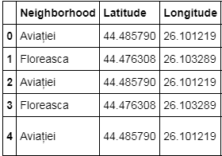

I will use populations of neighborhoods who has big population may need a new restaurant.

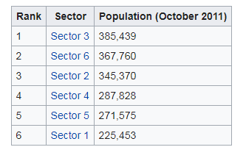 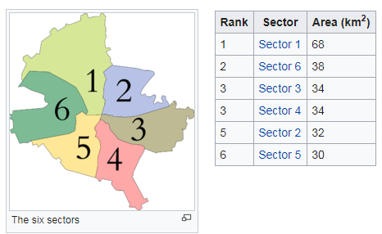

I will also classify neighborhoods by using venues distribution and counts. In this way, I will find similarities of neighborhoods which will help me to choose location for opening a new restaurant. Similar structured neighborhoods may handle same type of venue.

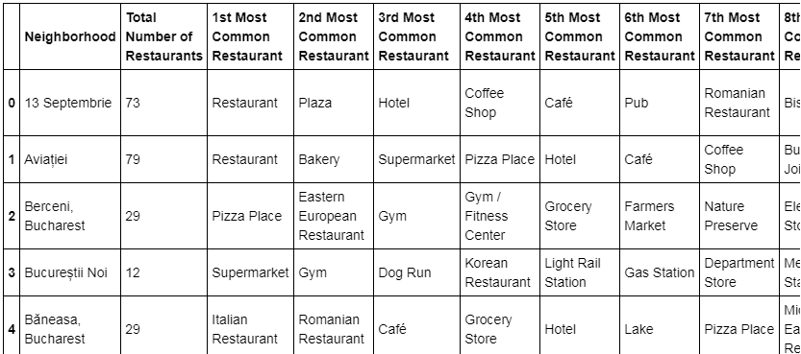

I will use venue list category to find distribution of restaurants and Turkish restaurants in neighborhoods.

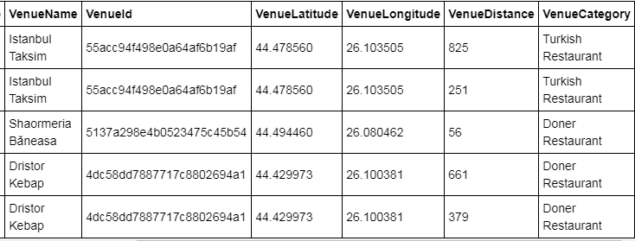

I will use also ratings and likes of restaurants in the areas. It may help me to find location with bad rating restaurants which may need a new restaurant.

